Basic Primer of VEXCODE: C++

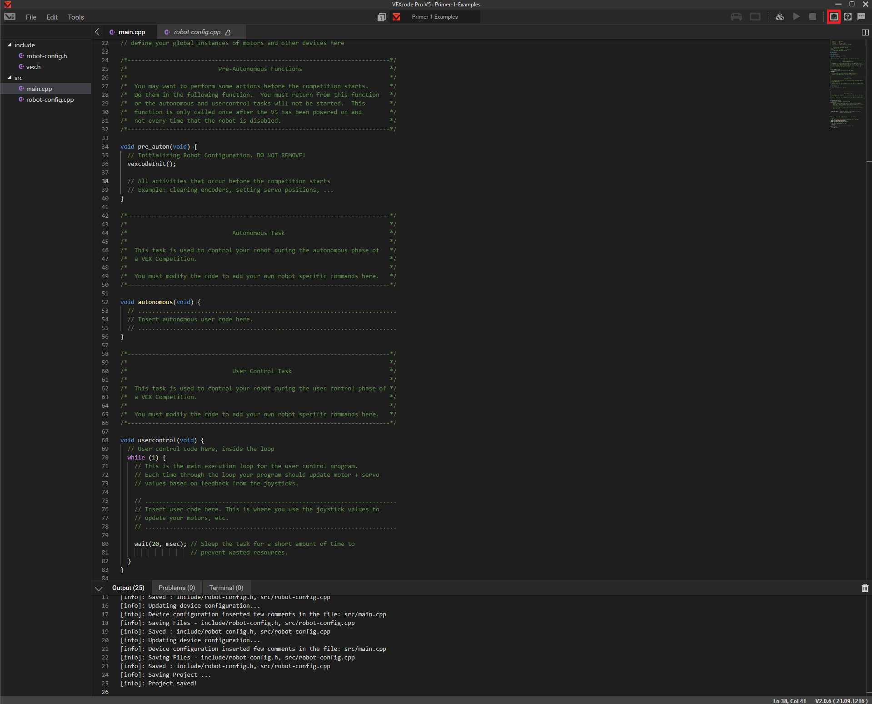Setting Up General Configuration

To first set up the motors, drivetrain and other objects, you must click the button highlighted in red. It will permit you to assign ports to the various motors and sensors connected to your brain. After clicking on it should show a tab with a plus sign and “Add a device”.

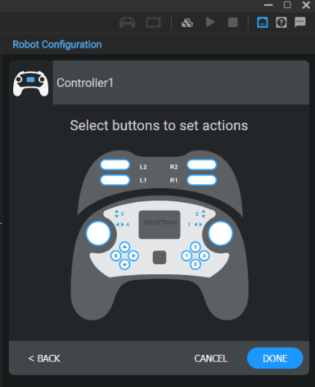Click on the said button and then click controller leading to this screen: Now click done and select add a device again but select drivetrain this time with the correct quantity of motors, if it is greater than 4, reference Appendix A: Exception 1. From here select the left motor ports starting with 1, then going in order of free odd ports (This is a convention, not a requirement). Once you have selected the left motors, proceed to selecting the right motor ports, just with even numbers this time. In the case that you have an inertial sensor, click inertial sensor and select that port. This then takes you to the following configuration page which is shown below. If you are using blue motor cartridges, then select the 6:1 ratio. If you are using green motor cartridges then do not change your choice, and if you are using red motor cartridges select 36:1. Then you select wheel size, and input gear ratio via inputting the starting gear, for example a 36 tooth, then the secondary gear, for example an 84-tooth gear. Additionally, if the drivetrain is completely reversed, click the down arrow centered on the drivetrain. Finally, click done at the bottom left of the configuration window. You may now reopen the Controller tab and click on the joysticks until the correct configuration appears. The diagram does a rather good job of explaining the possibilities, so I will leave that to it.

Next, to add motors you will select add a device yet again and then select, motor, a port, then a cartridge as previously referenced. Repeat this motor creation process unless you have a set of motors that you wish to have work as one. In that case select motorgroup.